Accessing M-Files on devices other than your Guild Computer

There are a few different ways you can access your M-Files account without your work computer.

- Adding M-Files to Android and iOS devices.
Download the M-Files app from your device’s App Store.

Once downloaded and accessed, you will be greeted with the server details login screen. Fill in with details provided below.

Server: https://m-files.guild.curtin.edu.au/
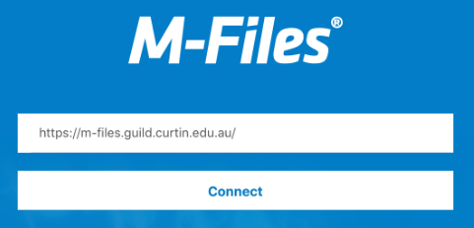
Select connect to bring up login details.

Your login details are the same as your Guild computer login details.
Username: Guild computer login
Password: Guild password
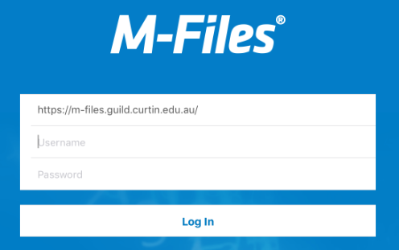

- Accessing M-Files with a browser.

You can also access M-Files through a browser, with the hyperlink below.
https://m-files.guild.curtin.edu.au/
Username: Guild computer login
Password: Guild password
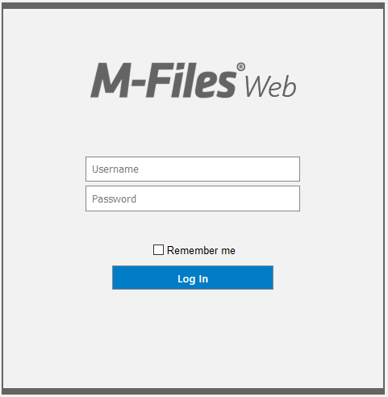

*Please note that some features won’t work as they do on the desktop application (Guild Computer) – This relates to both mobile app and browser access.

