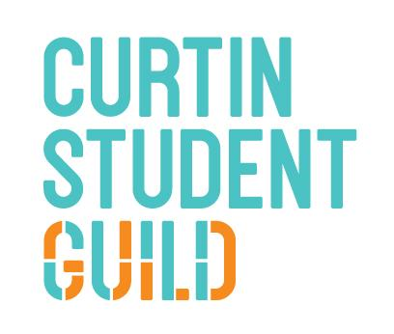
Student Guild of Curtin University
(COMMITTEE NAME)
Meeting # (number of meeting)
To be held at (Time) on (Day & Date) of (Month) 2021
In (Location)

MINUTES/AGENDA (pick one)
- Acknowledgement of the Traditional Owners:
“The Curtin Student Guild would like to pay our respect to the Aboriginal and Torres Strait Islander members of our community by acknowledging the traditional owners of the land on which the Bentley Campus is located, the Wadjuk people of the Nyungar Nation; and on our Kalgoorlie Campus, the Wongutha people of the North-Eastern Goldfields. We acknowledge and respect their continuing culture and the contribution they make to the life of this university, city and this region”
- Attendance:
  - Members Present;
  - Others Present;
  - Apologies and Leave of Absence
  - Absent

- Disclosure of any potential or perceived Conflicts of Interest

- Minutes of the Previous Meeting:
  - Previous Meeting Minutes
  - Any Circular Resolutions

- Matters Arising from the Minutes
  - Action List

- Significant Items

- General Business

- Next Meeting
The next meeting of the (INSERT COMMITTEE NAME) Committee will be on the (day & date) of (month) at (time) in (location).

