**HOW TO BOOK A GUILD MEETING ROOM / PROJECT SPACE THROUGH OUTLOOK**

1. To create a meeting through Outlook, you can either add it as a new item via your main inbox view:

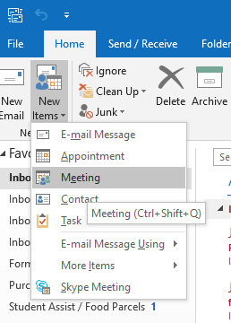

OR by double-clicking the relevant timeslot in your calendar and then clicking “invite attendees”:

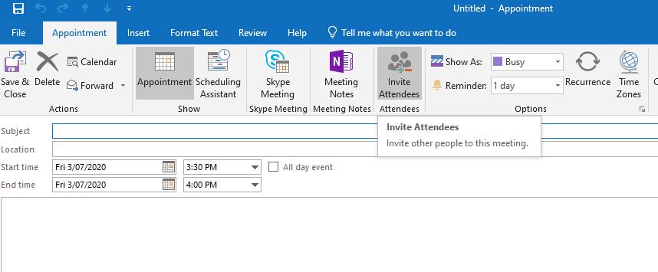

1. Once you have done this, click the box that says “Rooms”:

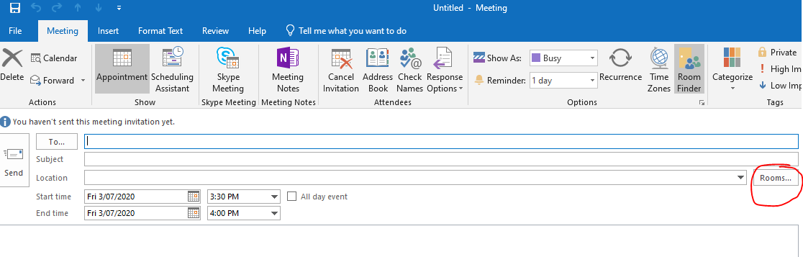

1. And select your required room: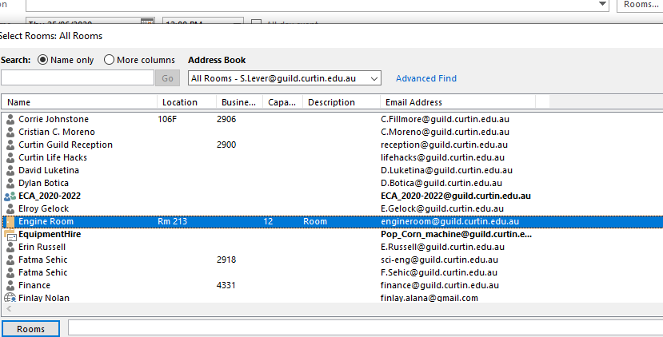
2. To check the room’s availability, you can do so by using “scheduling assistant” once you have added the room to the “meeting”:

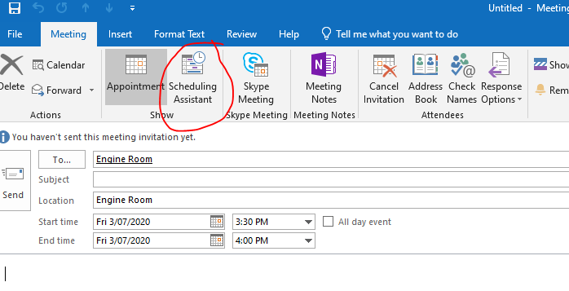

1. Which then brings up this view:

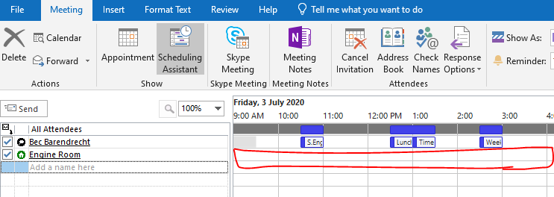

1. In the example above, you can then see that the room is free all day on that date. To confirm / book, simply click “send” in the top left corner once you have chosen your required time, or return back to “appointment” view to add further attendees and/or information.